RIPHAH INTERNATIONAL UNIVERSITY



NAME | ALIZA SHAHID
SAP ID | 56264
PROGRAMME | BSCS 3RD SEMESTER
COURSE | WEB DEVELOPMENT
LAB | 02 (Assignment)
SUBMITTED TO | MAM NAYAB KHALID

Task 1

Code:

<!DOCTYPE html>
<html>
<head>
<meta charset="UTF-8" />
<title>Task 1</title>
</head>
<body>
<form>
<h3> Personal Detail Form</h3>

<!-- First Name -->
<label for="fname">First Name: </label>
<br>
<input type="text" placeholder="Enter your First Name" required>
<br>
<br>

<!-- Last Name -->
<label for="lname" >Last Name:</label>
<br>
<input type="text" placeholder="Enter your Last Name" required>
<br>
<br>

<!-- Read-only City (Required) -->
<label for="city">City:</label>
<br>
<input type="text" placeholder="Enter your City" required>
<br>
<br>

<!-- Zip Code (Max Length 4) -->
<label for="zip-code">Zip Code:</label>
<br>
<input type="text" placeholder="Max Length 4" required>
<br>
<br>

<!-- Date of Birth -->
<label for="dob">Date of Birth:</label>
<br>
<input type="date" id="dob" name="dob" required><br><br>
<br>

<!-- Submit Button -->
<input type="submit" value="Submit">
</form>

</body>
</html>

Website:

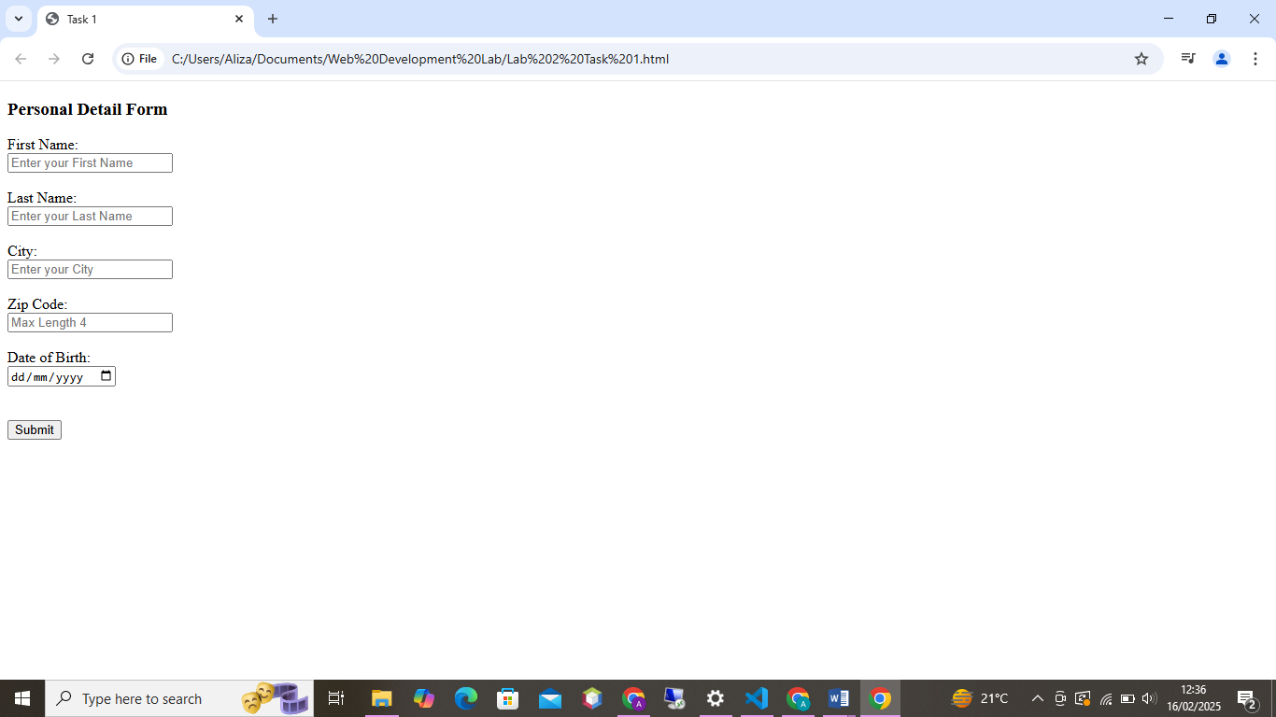

Task 2
Code:

<!DOCTYPE html>
<html>
<head>
<meta charset="UTF-8" />
<title>Task 2</title>
<style>
table {
width: 50%;
border-collapse: collapse;
margin: 20px 0;
font-size: 1.2em;
}
th, td {
border: 1px solid #ddd;
padding: 8px 12px;
text-align: center;
}
th {
background-color: #f2f2f2;
}
</style>
</head>
<body>
<h3>Student Academic Records</h3>

<table>
<tr>
<th>Student Name</th>
<th>Subject</th>
<th>Grade</th>
</tr>
<tr>
<td>Aleeza Shahid</td>
<td>Math</td>
<td>A</td>
</tr>
<tr>
<td>Amna Shahid</td>
<td>English</td>
<td>B+</td>
</tr>
<tr>
<td>Hadiqa Shahid</td>
<td>Science</td>
<td>A-</td>
</tr>
<tr>
<td>Mobeena Shahid</td>
<td>History</td>
<td>B</td>
</tr>
<tr>
<td>Subrina Shahid</td>
<td>Physics</td>
<td>B-</td>
</tr>
</table>

</body>
</html>

Website:

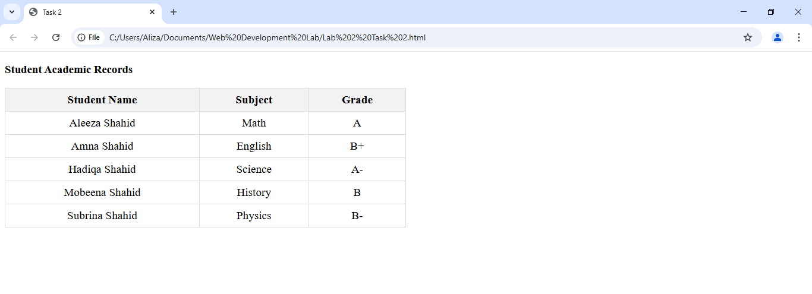
Task 3
Code:

<!DOCTYPE html>
<html>
<head>
<meta charset="UTF-8" />
<title>Task 3</title>
</head>
<body>
<form>

<h3>Registration Form </h3>
<body style="background-color: bisque;"></body>

<!-- First Name -->
<label for="fname">First Name: </label>
<br>
<input type="text" placeholder="Enter your First Name" required>
<br>
<br>

<!-- Last Name -->
<label for="lname" >Last Name:</label>
<br>
<input type="text" placeholder="Enter your Last Name" required>
<br>
<br>

<!-- Email -->
<label>Email:</label>
<br>
<input type="text" placeholder="Enter your Email/ Username" required>
<br>
<br>

<!-- Password -->
<label>Password:</label>
<br>
<input type="password" placeholder="Enter your password" >
<br>
<br>

<!-- Read-only City (Required) -->
<label for="city">City:</label>
<br>
<input type="text" placeholder="Enter your City" required>
<br>
<br>

<!-- Zip Code (Max Length 4) -->
<label for="zip-code">Zip Code:</label>
<br>
<input type="text" placeholder="Max Length 4" required>
<br>
<br>

<!-- Date of Birth -->
<label for="dob">Date of Birth:</label>
<br>
<input type="date" id="dob" name="dob" required>
<br>
<br>

<!-- Phone Number -->
<label for="phone">Phone Number:</label>
<br>
<input type="text" placeholder="0312-1234567" required>
<br>
<br>
<!-- Submit Button -->
<input type="submit" value="Submit">

</form>

</body>
</html>

Website:

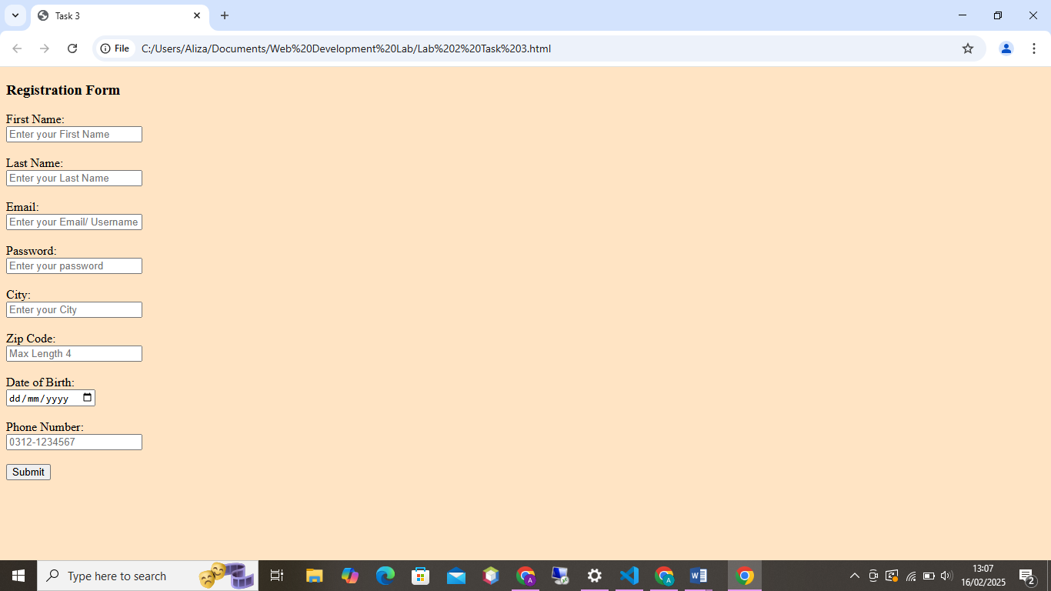

Task 4
Code:
<!DOCTYPE html>
<html>
<head>
<meta charset="UTF-8" />
<title>Task 4</title>
</head>
<body>

<h3>Seasons</h3>
<body style="background-color: mediumturquoise;"></body>

<!-- Spring -->
<h2>Spring</h2>
<p>This can be a really long description of spring, taking up an entire paragraph's worth of space.</p>
<p>There can even be several paragraphs describing the mild weather, blooming flowers, and renewal of nature.</p>

<!-- Summer -->
<h2>Summer</h2>
<p>You can also have one or more paragraphs describing summer. It's the time of hot weather, outdoor activities, and vacations.</p>
<p>Summer brings warmth and longer days, perfect for beach outings and barbecues.</p>

<!-- Autumn -->
<h2>Autumn</h2>
<p>Autumn is the season of falling leaves, cooler temperatures, and a transition to winter. Trees shed their leaves, and the weather becomes crisp.</p>
<p>It's a time for harvesting, sweater weather, and enjoying the colorful foliage as the world prepares for winter.</p>

<!-- Winter -->
<h2>Winter</h2>
<p>Winter brings cold temperatures, snow in many regions, and a time for cozy fires and warm drinks. Many animals hibernate, and days are shorter.</p>
<p>The season is marked by holiday festivities, icy landscapes, and opportunities for winter sports like skiing and snowboarding.</p>

</body>
</html>

Website:

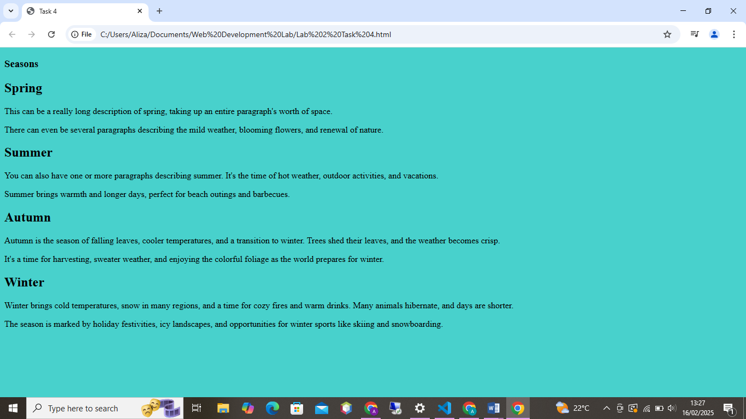

THE END!!

